**SQL COMMANDS**

DDL- DATA DEFINATION LANGUAGE: defines the structure/schema of database.

1.CREATE

2.DROP

3.ALTER

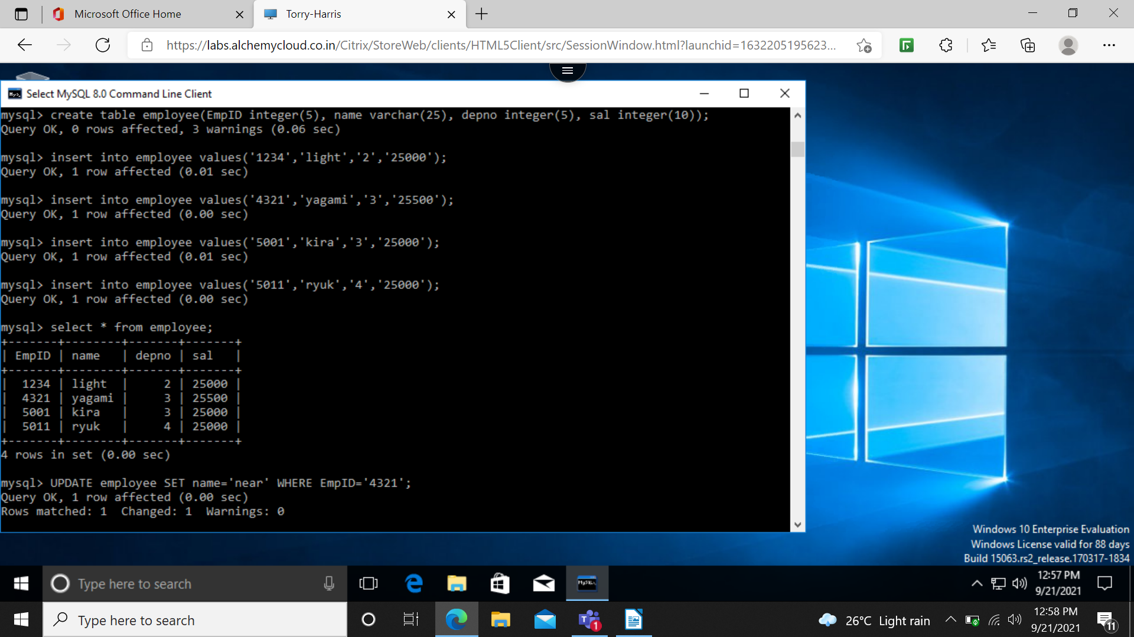

DML- DATA MUNIPULATION LANGUAGE: it is the sql that deals with manipulation of command

1.INSERT

2.UPDATE

3.DELETE

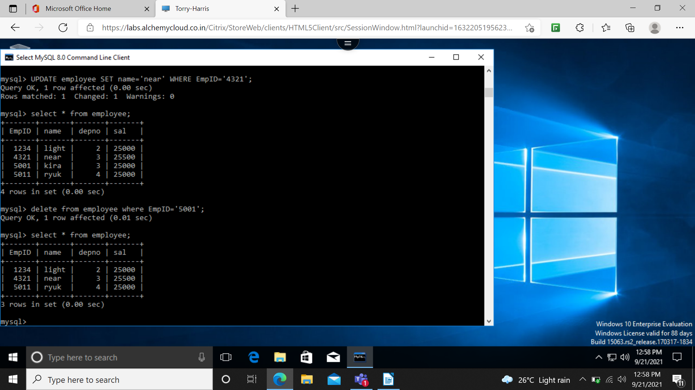

DQL-DATA QUERY LANGUAGE: used to perform query.  
1.SELECT

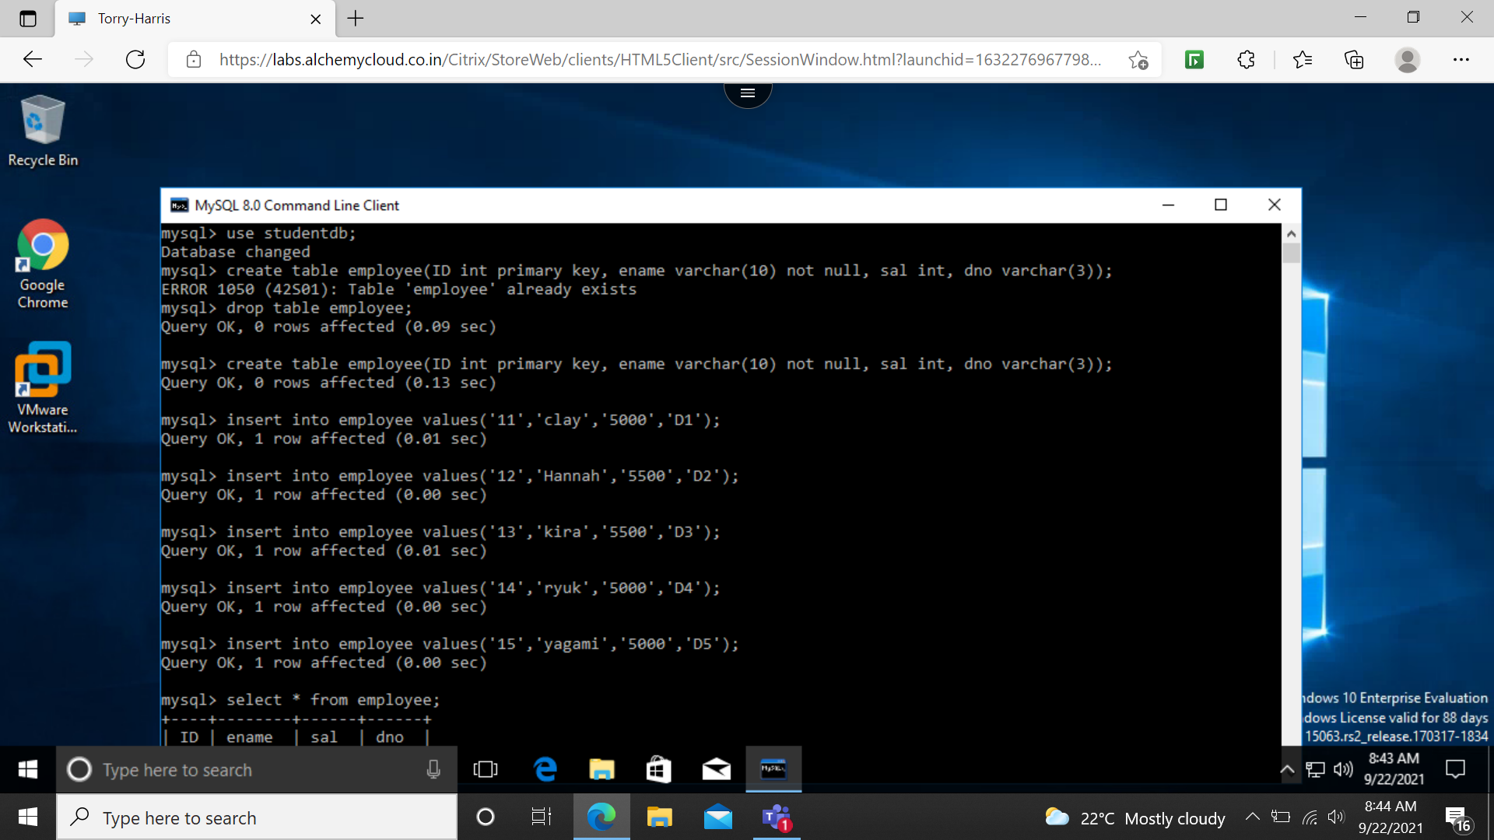

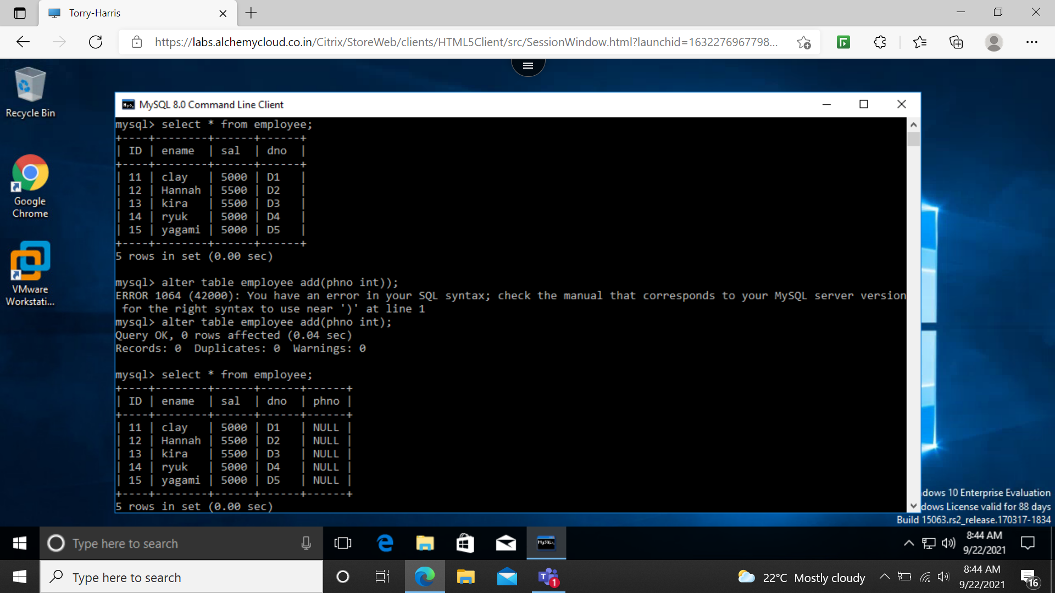

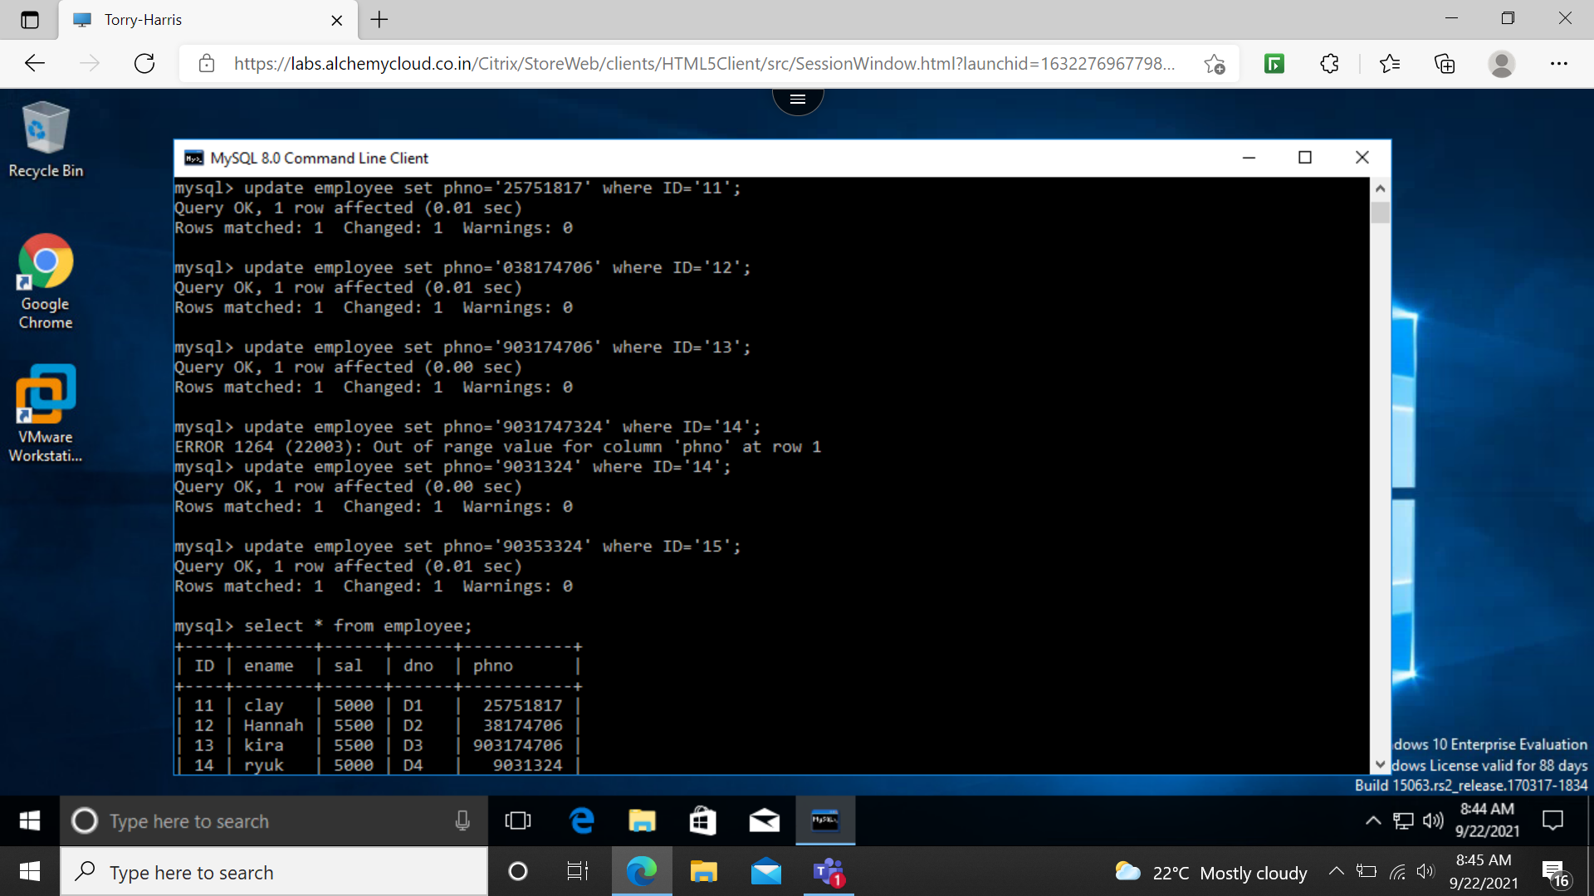

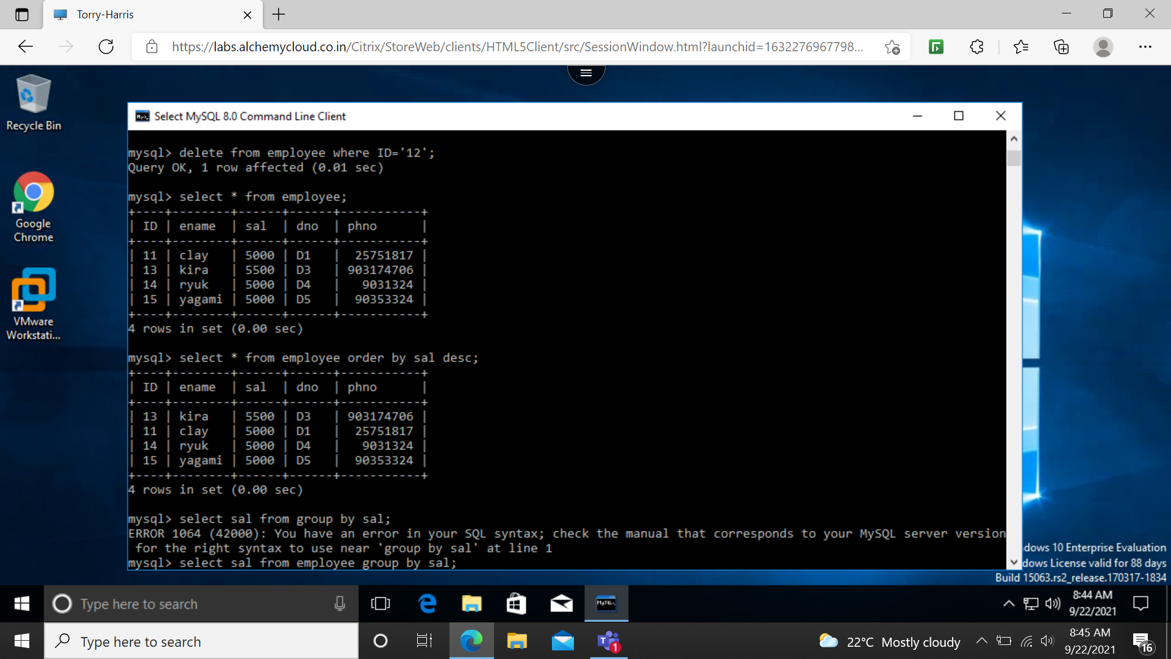

GROUPBY: used by aggregate function.

COUNT

HAVING: This clause can be used because where key word cannot be used with aggregate function.

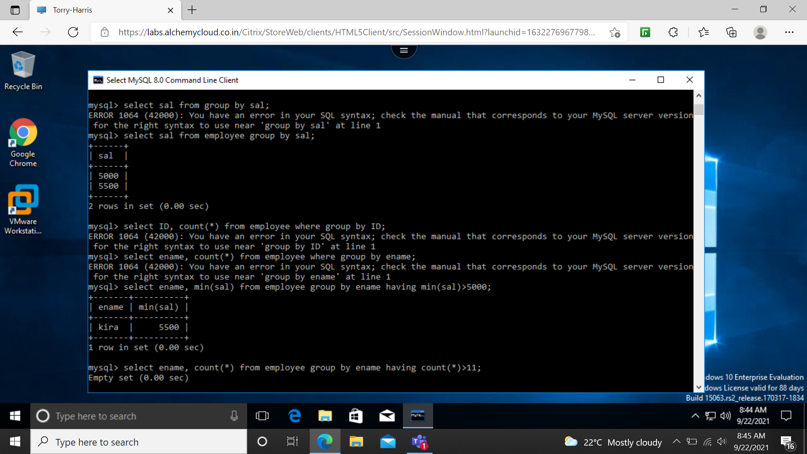

AGREGATE FUNCTION  
1.AVG 2.SUM 3.MIN 4.MAX 5. COUNT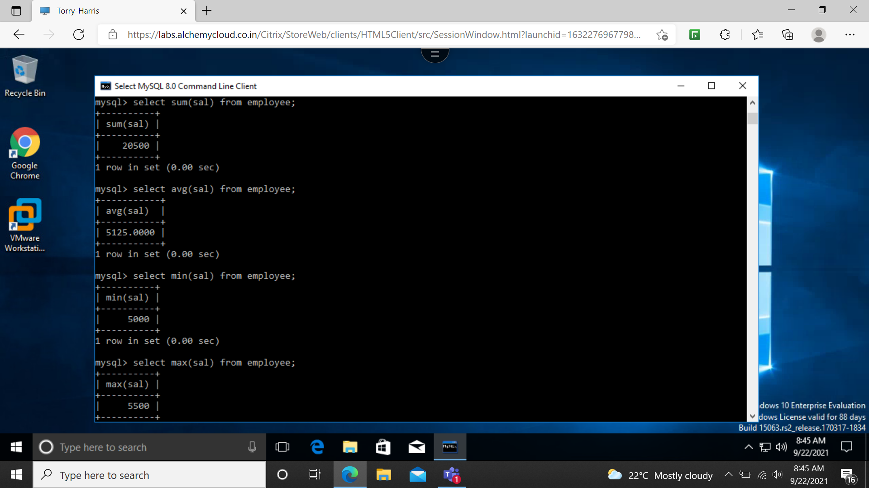

FOREIGN KEY: used to prevent actions that would destroy links between tables.

